Project Design Phase
Problem – Solution Fit Template

Date | 31 OCTOBER 2025
Team ID | NM2025TMID09063
Project Name | Laptop Request Catalog Item
Maximum Marks | 2 Marks

Problem – Solution Fit Template:
This template outlines the key steps to ensure the new ServiceNow Catalog Item effectively solves the challenge of manual laptop provisioning.
Purpose
The purpose of this Problem-Solution Fit template for the Laptop Catalog Item is to:
- Solve the complex problem of inefficient, non-standardized laptop requests in a way that fits the needs of end-users and the fulfillment team.
- Increase solution adoption by leveraging the existing Service Portal (an established channel) for all requests.
- Understand the existing manual situation (emails, spreadsheets) to improve it for the target group (employees and Hardware/IT teams).
- Increase touch-points with the system by providing a clear, trustworthy channel for an urgent and frequent request.

Template:
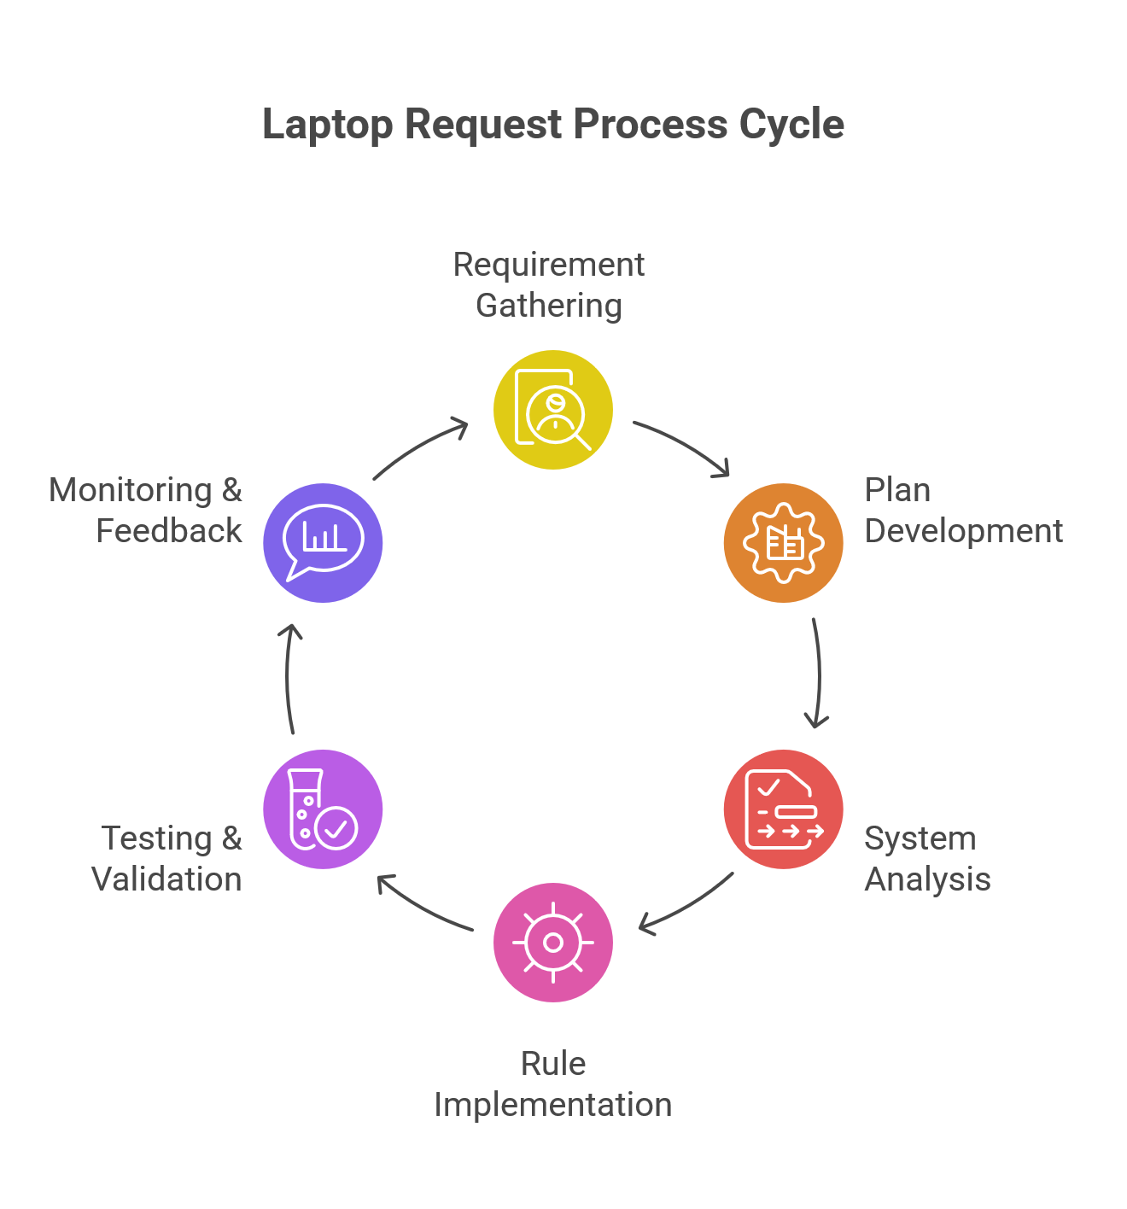

This project successfully established the framework for implementing an automated and user-friendly Laptop Requesting Catalog Item within the ServiceNow platform. By adopting a structured problem-solving approach—including brainstorming, idea prioritization, and a problem-solution fit analysis—we have laid the foundation for a significant IT process improvement.

